Connecting GitHub to local Repository
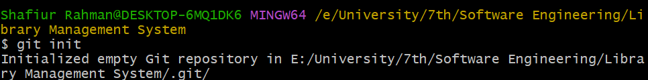
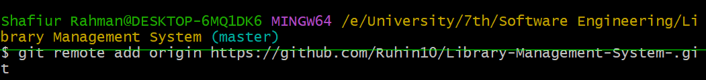
Creating new Branch Named “feature-R”
Adding UI Design Docx File
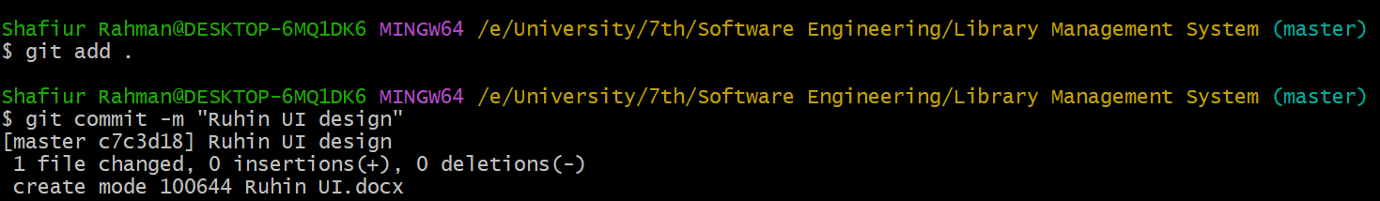
Pushing local Repo to GitHub Repo
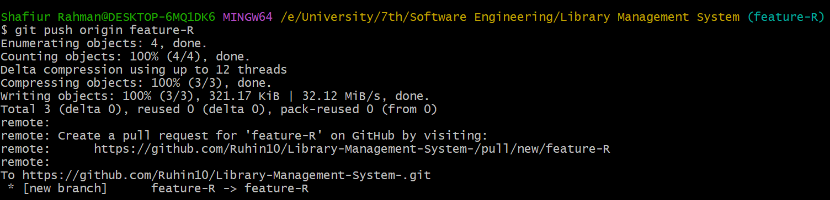

Adding Class Diagram and Use Case Diagram and Pushing to GitHub Repo
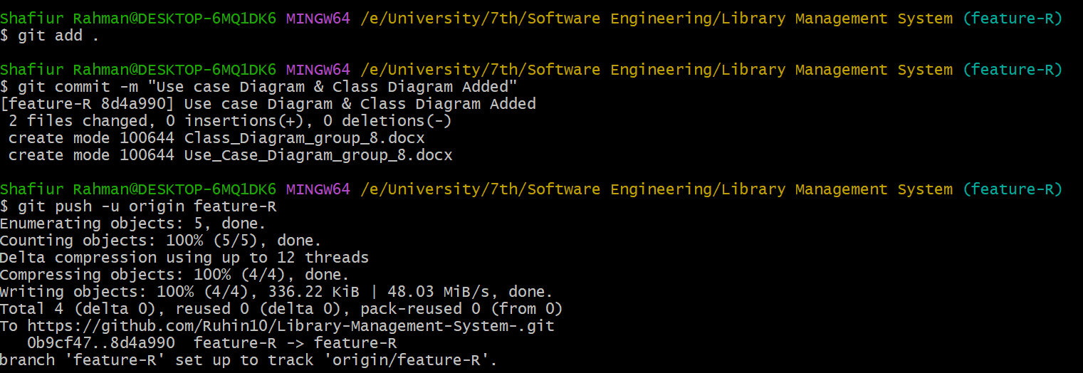
Adding Background of the project to GitHub Repo
